Five Layer Repair in Management of sacrococcygeal Pilonidal Sinus

A.T.Barakat¹, M.M.Rizk¹, E.M.Kilany¹ and E.M.Oraby¹
¹General Surgery Dept., Faculty of Medicine, Benha Univ.,Benha, Egypt
E-Mail:Barakat2@gmail.com

Abstract

Pilonidal disease is a common surgical problem primarily affecting young men between puberty and early thirties and is estimated to affect 26 per 100 000 individuals. surgery is still the primary method of treatment of the disease. Surgical management is usually simple, inexpensive, and is associated with a short hospital stay and rapid wound recovery. The aim of this study was to describe the effect of 5 layers repair technique in the management of pilonidal sinus as regard postoperative efficacy and results regarding pain,wound healing and recurrence. the study included 20 patients with a history of discharge from sacrococcygeal region that is clinically diagnosed as pilonidal sinus. Patients were treated by excision of the whole track till the pre sacral fascia and periosteum (Five Layers Repair) There mean age of patients was 31 years and 18 patients were males, 3 patients presented with discharge only , another 6 with pain and 11 patient presented with both pain and discharge. Mean time to wound healing was 12 (±2), while Mean time to removal of stitches was 14( ±1) and 30(+-)9 days was to return to work (±1), 19 patient came with complete healing and only 1 patient showed wound beakdown. Reccurence didn’t happened to any patient after 3-12month of surgery. Our findings indicated that 5 layers repair technique was superior to other techniques in terms of less operative time, less post-operative VAS of pain, no rate of recurrence presented with patients in our study.

Keywords: Pilonidal; Sinus; Five Layers; Repair

- Introduction

Pilonidal sinus disease {PNS} is a simple chronic inflammatory condition resulting from loose hairs forcibly inserted into vulnerable tissue in the natal cleft. It is an acquired disease with a slight familial tendency. There is no agreement on optimum treatment and the multitude of therapeutic options cannot be compared due to the lack of a universally adopted classification of the disease [1].

Pilonidal sinus disease is mostly an acquired condition, usually seen in young adults, that carries high postoperative morbidity and patient discomfort. The most important predisposing factors for the development of pilonidal sinus are the existence of a deep natal cleft and the presence of hair within the cleft. Thus, for treatment and prevention, these causative factors should be eliminated [1].

Pilonidal sinus healing by secondary intention often takes weeks to months;. A number of new surgical approaches may accelerate healing. Surgical closure by primary intention is often associated with higher recurrence rates [2].

In 1946, Limberg first described a technique for closing a 60° rhombus-shaped defect with a transposition flap. Dufourmentel modified this technique in 1962 to close defects with any acute angle. Webster published a third significant modification in 1978. The Webster, or 30° flap, uses a 30° angulation of the distal flap end along with an M-plasty closure at the defect base [4].

This utilizes a rhomboid transposition flap to cover the defect left after radical excision. The results show healing by first intention in 29 out of 30 patients. No patient remained in hospital for more than ten days. Minor infection took place in five cases and major infection in one case. Patients have been followed for up to three years. No recurrence has yet been encountered [5].

Excision and Primary Closure—An elliptical excision that includes some of the lateral margin is excised down to the level of the fascia. Adjacent lateral tracts may be excised by expanding the incision. To close the wound, edges are approximated with placement of deep and superficial sutures. Wound healing typically occurs faster than secondary granulation, as seen in one randomized controlled trial with a mean of 10 days for primary closure compared to 13 weeks for secondary intention. However, as with any surgical procedure, postoperative complications can delay wound healing. The recurrence rate after primary closure varies considerably, ranging from 10% to 38%.20 [6].

There is published literature supports the use of the rhomboid flap excision and the Limberg flap-repair procedures over primary midline suture techniques for the elective management of primary pilonidal disease. Further high-quality studies are necessary to compare flap with off-midline repairs [7].

The choice of treatment options depends on the acute or recurrent presence of the disease. So far conservative treatment options as for example laser and light treatment, and various surgical options are in use. They range from incisions, excision techniques with primary or secondary wound closure over minimal invasive procedures as pit excision and marsupialization up to various flap techniques as plastic surgery methods. Due to the variety of clinical symptoms and appearances the gold standard for surgical treatment for pilonidal sinus is still under debate [8].

In this study we used a new technique to repair the 5 layers. excision of the whole track till the pre sacral fascia and periosteum to reduce the incidence of recurrence as the main postoperative complication.

The aim of this study was to describe the effect of 5 layers repair technique in the management of pilonidal sinus as regard postoperative efficacy and results regarding pain, wound healing and recurrence.
- Patients and methods

This prospective study was carried out in general surgery department, Benha university hospitals. It included 20 patients who had sacrococcygeal primary pilonidal sinus. Patients that included in our study are symptomatic complaints diagnosed as pilonidal sinus were enrolled in our study. All casea werw done from 1/5/2019 to 1/5/2020.

An informed written consent was taken for every patients were involved in the study. An approval from the research ethics committee in Benha Faculty of Medicine was obtained. The study was approved by the ethical committee of Benha faculty of medicine.

2.1Inclusion criteria:
- Patients from 20-50 years old.
- All patients with 1ry pilonidal sinus.

2.2Exclusion criteria:
- Age less than 20 or more than 50 years.
- Patients with comorbidities ( e.g. D.M. , HTN , Cardiac diseases , etc… )
- Actively Infected sinus.

All patients were subjected to history taking, clinical examination, routine laboratory investigations: complete blood count(C.B.C), ALT, AST, Urea, Creatinine, blood sugar , and INR. Patients were treated by excision of the whole track till the pre sacral fascia and periosteum (Five Layers Repair) as shown in Fig (1-5)

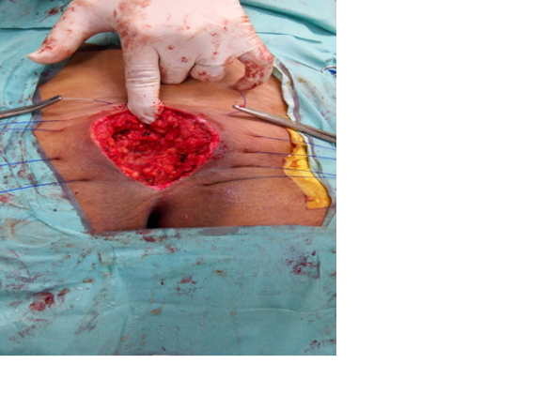

Fig(1) release incision after excision of track with tension sutures

Fig (2) closure of medial aspect of scarp`s fascia

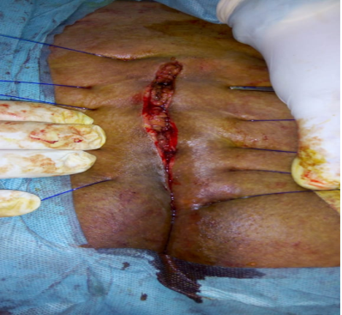

Fig(3) closure of scarp`s fascia approximating edges

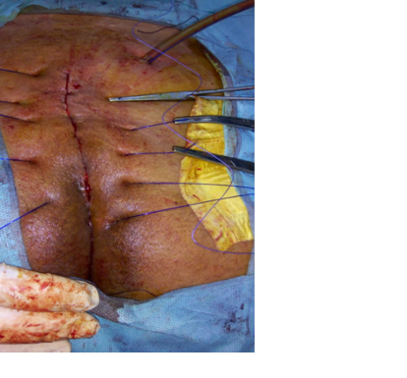

Fig(4) closure of subcuteanous tissue

Fig (5) closure of tension sutures on tie over small dressing

2.3Statistical Analysis

The collected data was tabulated and presented in suitable Figs. Quantitative data was summarized using mean and standard deviation, while, qualitative data by using frequency and percentage. Data was analyzed by the aid of software package of SPSS using suitable statistical tests. The accepted level of significance in this work was 0.05 (P<0.05 was considered significant).

- Results

This study was conducted on 20 patients with a history of discharge from sacrococcygeal region that is clinically diagnosed as pilonidal sinus. The mean age of patients was 31 years. and 18 patients were males (Table 1)

Table (I) demographic data:
Age (years) | Mean ±SD | 31 ±8
Gender | Males n (%) | 18 (90.0)
 | Females n (%) | 2 (20.0)
BMI | Normal n (%) (20 – 25) | 6 (30.0)
 | Obese n (%) ( 25 – 30) | 4 (20.0)
 | Overweight n (%) (30 – 35) | 10 (50.0)
Total |  | 20
BMI = Body mass index
Three patients presented with discharge only, 6 of them with pain and 11 patient presented with both pain and discharge, (Fig 6)

Fig (6) Frequency distribution of presenting symptoms in both groups
Mean operative time was (35 min), while Median Visual Analogue scale for pain assessment was 6 ranges from 5 to 7., Mean hospital stay was 1 (±0.31). Mean time for wound healing was 12 days (±2), while Mean time for removal of stitches was 14( ±1) and 21 days was to return to work (±1) (Table II )
Table (II) Operative & post-operative data
 |  | (n = 20)
Operative time (min) | Mean ±SD | 35 ±8
Post-operative pain (VAS) | Median (range) | 6 (5 - 7)
Hospital stay (days) | Mean ±SD | 1 ±0.31
Time to wound healing (days) | Mean ±SD | 12 ±2
Time to removal of stitches (days) | Mean ±SD | 21 ±1
Time to return to work (days) | Mean ±SD | 30±9
Post-operative complications: 19 patient came with complete healing and only 1 patient showed wound breakdown due to wound infection. Reccurence didn’t happened to any patient after 6 month of surgery (Table III)
Table (III) Frequency distribution of post-operative complications
 |  | (n = 20)
Complete healing | Yes n (%) | 19 (95.0)
Wound breakdown | Yes n (%) | 1 (5.0)
Recurrence | Yes n (%) | - (0.0)

- Discussion

In this study, according to BMI of patients was 20% were obese and 50.0% were overweight. On the other side a study done by Samir et al., [9], reported that 60 % of patients were obese and 26.6% were overweight. Obesity was higher in the study done by Hassan et al., [10], It was reported that 80% of patients were obese.

In this study, {15%} 0f patients (3 patients) presented with discharge only , {30%} of them ( 6 patients) with pain and {55%} of patient (11 patients ) presented with both pain and discharge. This was consistent with study done by Samir et al., [9], that reported that 26.6% of patients complained of pain, 20.0% complained of discharge and 46.6% complained of pain and discharge. Mustafa et al., [11] reported similar percent of those complaining of pain {35.8%} but it was reported that higher percent of those complaining of discharge {72.4%}.

In this study, we reported that mean operative time was {35 minutes}. the studies done Samer et al., [9], Turgut et al., [12], reported higher operative time in rhomboidal flap technique and Karydakis technique. that mostly due to extensive dissection, adjustment of flap and closure of wound.

In this study, we reported that median VAS was {6}. in Mustafa et al., 2011 [11] study, VAS was higher in patients underwent Karydakis technique which was { 7.08 ± 1.75 }. In contrast, Turgut et al., [12] reported that pain was lower using Karydakis technique{3.7 ± 1.7} .

In this study we reported that mean hospital stay was {1 day±0.31}. This was lower than a study done by Mustafa et al., [11] which reported longer hospital stay in in all techniques used in the study{3.40 ± .94}.

Our explanation is in other techniques uses flap, we need to make sure that flap is viable with adequate blood supply and there is no tension by sutures .Studies done by, Samir et al., [9] and Turgut et al., [12] also showed longer hospital stay in in all techniques used in the study.

According to this study, mean time to removal of stitches was {14 days}. in study done by Samir et al., [9] the mean time for remove stitches was {13.66 day} using limberg flap.

In this study, we reported that mean time to return to work was {21 days} as patients are able to set. This time is a bit longer than other many studies which vary between {12 to 18 days} but due to extensive dissection in out technique {multiple layer of clousure}, patients needed more time to return to work

We reported in this study no reccurence rate and only a case of Wound breakdown. In Kose, et.al., [13] study which included a total of 802 patients who were operated on for pilonidal sinus in many techniques {primary closure, Limberg, and modified Limberg flap techniques} The reccurence rate was about {12%} in average to all techniques used in the study .

Traditional techniques have aimed to remove the area of chronic inflammation as well as any potential remaining nidus of infection, with healing achieved via secondary intention or primary coverage with surrounding tissue flaps. The feature of the flap is to create a wound off the midline to allow healing and also to decrease the recurrence of the disease. [14]

It perhaps unsurprising that open surgical wounds that are left to granulate take longer to heal than surgically closed wounds. Interestingly, wounds closed on the midline of the natal cleft took longer to heal compared with wounds closed off-midline, that may led to infection and other complication and previous studies showed recurrent cases. Recurrence of pilonidal sinus was the most commonly reported outcome by all the included studies [15].

Studies that involve different surgical techniques for treatment of PSD have reported contradicting results in terms of recurrence rates. Likewise, it is not always possible to confirm the results obtained in comparative studies. The inability to control variables related to surgical technique, patients, and disease often contributes to a high level of variation between studies. Factors related to surgical technique, patients, and disease may have a strong effect on recurrence rates following surgical treatment of PSD [13].
- Conclusion

Our findings indicated that 5 layers repair technique was superior to other techniques in terms of less operative time, less post-operative VAS of pain. These critical benefits of our technique minimize the recurrence rates of PNS.
- References
[1] K. H. Abu Galala ,“Treatment of pilonidal sinus by primary closure with a transposed rhomboid flap compared with deep suturing: a prospective randomised clinical trial,” Eur. J. Surg, vol. 165(5), pp. 468–472, 1999.
[2] C. Harris, R. G. Sibbald, A. Mufti, “Pilonidal sinus disease: 10 steps to optimize care,” Adv. Skin Wound Care, vol. 29(10), pp. 469–478, 2016.
[3] L. L. Ackerman , A. H. Menezes, “Spinal congenital dermal sinuses: a 30-year experience,” Pediatrics, vol. 112(3), pp. 641–647, 2003.
[4] K. Akan, D. Tihan, U. Duman, “Comparison of surgical Limberg flap technique and crystallized phenol application in the treatment of pilonidal sinus disease: a retrospective study,” Turkish J. Surgery/Ulusal cerrahi Derg, vol. 29(4),pp. 162, 2013.
[5] O. F. Akinci, M. Kurt, A. Terzi, “Natal cleft deeper in patients with pilonidal sinus: implications for choice of surgical procedure,” Dis. colon rectum, vol. 52(5), pp. 1000–1002, 2009.
[6] M. Aldemir, İ. H. Kara, G. Erten, “Effectiveness of collagenase in the treatment of sacrococcygeal pilonidal sinus disease,” Surg. Today, vol. 33, (2), pp. 106–109, 2003.
[7] H.k. Al-Hassan, I. M. Francis, P. Neglen, “Primary closure or secondary granulation after excision of pilonidal sinus?,” Acta Chir. Scand, vol. 156, (10), pp. 695–699, 1990.
[8] A. Ahmed, I. McCallum, P. M. King, “Healing by primary versus secondary intention after surgical treatment for pilonidal sinus,” Cochrane database Syst. Rev, vol. 1(1), pp. 54, 2010.
[9] S. M. Kohla, A. A. Alsesy, T. F. Abd El-Aziz, “Comparative study between the Karydakis technique and the Limberg flap in pilonidal sinus,” Menoufia Med. J., vol. 29(3), p. 539, 2016.
[10] D. H. D. Al Traifi, K. S. D. Anwar, M. D. Ashraf, “Clinical features and surgical management of sacrococcy geal pilonidal sinus: experience of a peripheral hospital in Saudi Arabia,” World J. Color. Surg, vol. 1(1), p. 7, 2009.
[11] M. Ates, A. Dirican, M. Sarac, “Short and long-term results of the Karydakis flap versus the Limberg flap for treating pilonidal sinus disease: a prospective randomized study,” Am. J. Surg, vol. 202(5), pp. 568–573, 2011.
[12] T. Karaca, Ö. Yoldaş, B. Ç. Bilgin, “Comparison of short-term results of modified Karydakis flap and modified Limberg flap for pilonidal sinus surgery,” Int. J. Surg, vol. 10(10), pp. 601–606, 2012.
[13] E. Kose, M. Hasbahceci, H. Tonyali, “Comparative analysis of the same technique-the same surgeon approach in the surgical treatment of pilonidal sinus disease: a retrospective cohort study,” Ann. Surg. Treat. Res , vol. 93(2), pp. 82–87, 2017.
[14] K. T. Choy , H. Srinath, “Pilonidal disease practice points:’An update’,” Aust. J. Gen. Pract , vol. 48(3),pp. 116, 2019.
[15] A. Saber, “Modified off-midline closure of pilonidal sinus disease,” N. Am. J. Med. Sci, vol. 6(5), pp. 210, 2014.

